Submit your typing speed here:

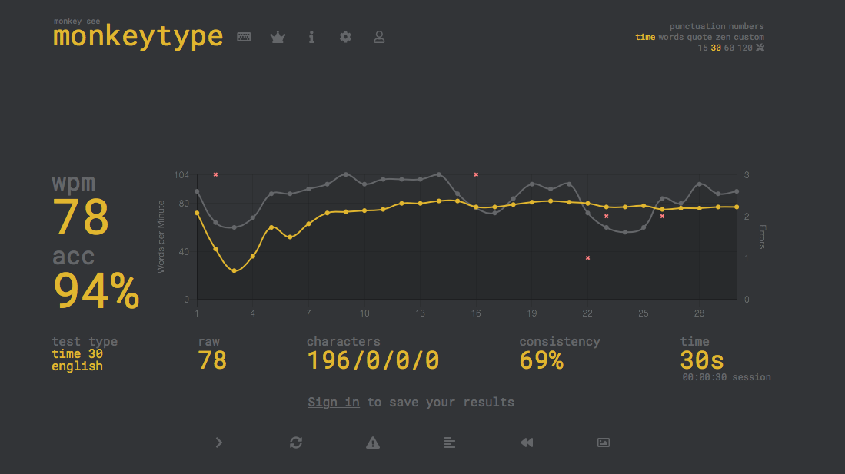

Write a 5 sentence paragraph on how well you think you did at typing!

I think I did pretty well at the typing test as I made a few errors but had a 94% accuracy. I think I could have improved by focusing more, as I usually go autopilot mode. How I plan to improve this is by taking more tests or doing more of those exercises in typingclub. In the future I want to type consistently 85 wpm because that's pretty good. Another way I could improve my typing is probably just being on the computer more. Being on the computer more means I will probably be texting/typing more.

Example Questions: (Feel free to talk about anything else!)

What went well?

What can be improved?

How will you plan to improve your typing skills?

How fast do you want to type?